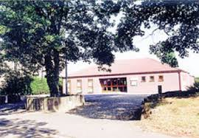 | Bicker Village Hall  Hiring Agreement |  |  | 
Date booking made:
Bicker Village Hall Management Committee
Authorised Representative: |  |  | Sonia Pallett
Address: |  |  | Tarn Hows, Gauntlet Road, Bicker, PE20 3AU
Telephone Number: |  |  | 01775 820652
Hirer:
Organisation and
Authorised Representative:
Address:

Telephone Number:
Purpose of hire:
Period of hire:
Date/time
Hiring Fee: |  |  | £
Less 50% deposit:  Paid to secure booking |  |  | £
Balance:  Paid 1 month before hiring |  |  | £
Premises:
Gedney room/main hall/ whole of village hall/bowling green
Bar required/applied for:
The Hirer agrees with the Committee to observe and perform the provisions and stipulations contained or referred to in the Committee’s ‘Standard Conditions of Hire’ and ‘Special Conditions of Hire’.
Signed and dated:
On behalf of Bicker Management Committee
Signed and dated:
The Hirer

